Report - F1 Clustering Project
Roee Amsalem, Oren Yehezkel, Ido Brener
1 Abstract:

In this data-science project, we have aimed to answer two main questions:
- Can different F1 driving styles of different drivers be found using only telemetry data from a few races?
- Which driving styles exist? What characterizes them?
To answer these questions, we found a way to export telemetry data from official F1 races using OpenF1 project’s API. At first, we exported 1,653,153 lines of telemetry data collected on 4 official F1 races (Monza, Singapore, Spa, Suzuka) and then processed it using feature engineering into 1109 samples, each representing a turning event a certain driver made during his fastest lap in each race, which became the final dataset of this project.
To reach the desired conclusions from the dataset, we used dimensionality reduction using the PCA algorithm, then performed clustering once on the datasets, grouped the turns by driver, and performed clustering once more to get different driving styles by drivers.
Finally, we have reached outstanding conclusions:
- Drivers indeed have different driving styles: aggressive, balanced, and conservative, each with its unique characteristics.
- The drivers control the driving style: we were able to rule out the “car decides the result” hypothesis, by seeing that drivers from the same team, who drive the same car, ended up having different driving styles.
- The more aggressive the better: if the driver has a more aggressive driving style he is expected to reach a better standing on average.

2 Introduction:

Formula 1 is widely regarded as the pinnacle of both motorsport and automotive engineering. In recent years, the sport has undergone a massive paradigm shift, evolving into a highly data-driven domain. A modern F1 car is equipped with hundreds of sensors that transmit vast amounts of real-time telemetry data –including throttle application, braking pressure, and steering angle.
Historically, data science applications in F1 have primarily focused on vehicle performance and race strategy. Prominent past projects and industry applications typically revolve around predictive modeling for tire degradation, pit-stop optimization algorithms, and aerodynamic efficiency analysis.

In the industry, the partnership between Formula 1 and AWS highlights the shift toward data-driven racing. The "F1 Insights" platform processes millions of telemetry data points per second to train real-time machine learning models. These models evaluate metrics such as driver braking performance and cornering speeds to predict overtake probabilities, demonstrating how raw car data is actively used to quantify complex driver actions on the track.

The recent study "Data-driven pit stop decision support for Formula 1" demonstrates the specific application of machine learning to race strategy. The researchers trained advanced models, including neural networks, on historical race data to predict the mathematically optimal pit-stop window. By replacing human intuition with rigorous modeling of tire degradation and track conditions, this specific research highlights how deep learning algorithms can extract highly accurate, objective decisions directly from complex F1 datasets.

On the open-source front, unsupervised learning has already proven effective for F1 categorization tasks. A notable project utilized clustering algorithms alongside dimensionality reduction techniques like PCA to categorize F1 circuits into distinct profiles based entirely on technical characteristics. This approach validates the use of unsupervised machine learning to extract natural, objective groupings from complex, unlabeled F1 datasets.

However, while machine learning has effectively modeled the car, evaluating the human element remains a complex challenge. There is a growing need for projects that leverage telemetry data to quantify driver behavior and psychology. Understanding how different drivers interact with similar machinery holds significant potential. Profiling drivers based on their natural instincts – such as aggression under braking or smoothness through apexes – can revolutionize how teams tailor car setups, scout new talent, and predict on-track rivalries. This intersection of human skill and raw mechanical data makes F1 a prime landscape for advanced behavioral data science.

3 Methods

3.1 Dataset Description:
The initial dataset consists of 28,068 raw telemetry records collected from four official Formula 1 circuits (Monza, Singapore, Spa, and Suzuka), extracted utilizing the OpenF1 API. The data is structured as a time-series, where each record represents a momentary snapshot of a specific car's telemetry and spatial position during a race.
The raw dataset includes the following foundational features:
- Identifiers: track (circuit name), driver_number (unique driver ID).
- Temporal & Spatial: lap_duration (total lap time), x and y (2D spatial coordinates of the car).
- Mechanical Telemetry: speed (velocity), brake (braking indicator), throttle (throttle pedal application percentage), n_gear (current engaged gear), and rpm (engine revolutions per minute).

3.2 Exploratory Data Analysis – Raw Data:
Feature distributions:
Feature_Name | Minimum | Maximum | Mean | Median | Standard_Deviation
speed | 50 | 350 | 223.9458 | 234 | 74.5259
n_gear | 2 | 8 | 5.7148 | 6 | 1.9139
throttle | 0 | 100 | 71.7619 | 99 | 40.0555
brake | 0 | 100 | 16.3874 | 0 | 37.0168
x | -13708 | 11068 | -1043.9124 | -416 | 5947.2782
y | -15771 | 15883 | -1005.0467 | -616 | 7179.7117

Missing Values:
While the OpenF1 API inherently filters out standard technical missing values (e.g., damaged sensors), the EDA revealed "theoretical" missing values. Specifically, telemetry sensors pause data generation for several seconds at the start and end of laps. These gaps were identified as noise that could falsely register as cornering events, prompting us to implement an algorithmic filter to remove them.

Outliers:
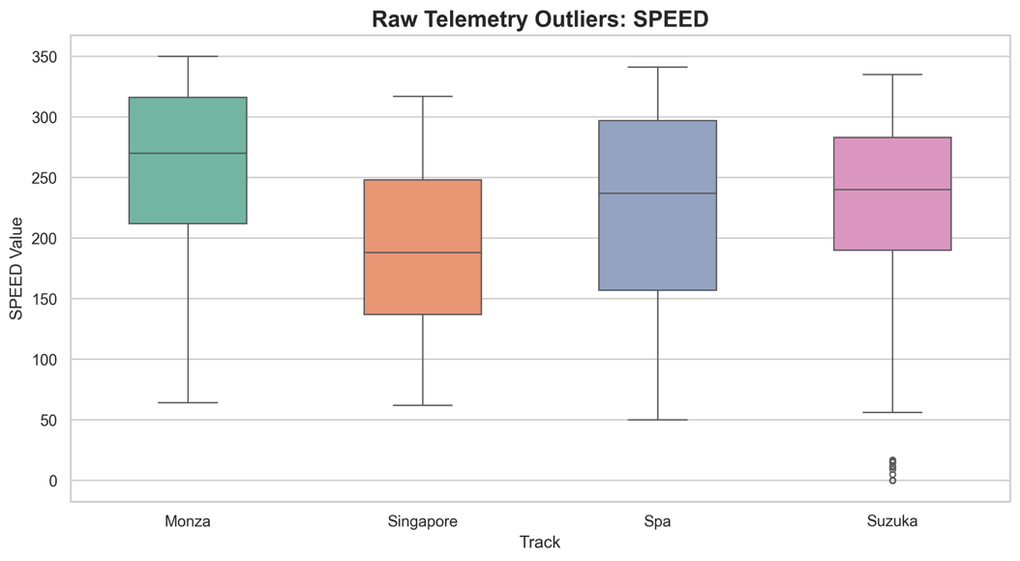
There are almost no extreme outliers, and those that exist are mostly the measurements errors, we can look for example on the box plot for the speed of the drivers:
Figure 1: Outlier Detection for Speed by Track.

3.3 Preprocessing:

Data Filtering & Cleaning:
To extract relevant insights, the dataset was filtered to isolate meaningful events. This process included two main steps: extracting only the fastest lap recorded by each driver in each race, and isolating the specific time-samples that occurred during cornering events.

Data Limitations & Noise Handling:
During preprocessing, we addressed two primary data irregularities:
- Low Sampling Resolution: The telemetry data operates at a sampling rate of approximately 3.7Hz (a 0.25-second gap between samples). At racing speeds of 200 km/h, a car covers roughly 15 meters between data points. While this sparsity could theoretically obscure micro-behaviors, the massive volume of collected data effectively mitigates its impact on the clustering performance.
- Sensor Gaps (Noise): Telemetry sensors occasionally pause data generation for a few seconds at the start and end of a lap. Due to the spatial nature of our corner-detection calculations, these gaps were erroneously registered as turns. We implemented an algorithmic filter to detect and eliminate these noise-affected anomalies from the dataset.
Feature selection:
To capture quantifiable behavioral patterns, the raw time-series data was transformed into discrete cornering events, yielding a refined dataset of 1,109 samples. To analyze driver behavior through these corners, we engineered 12 targeted features, categorized as follows:
- Identifiers: track, global_corner_id, and driver_number.
- Speed Dynamics: entry_speed, apex_speed, exit_speed, speed_drop (the difference between entry and apex speeds), and avg_speed.
- Braking Behavior: braking_time_pct (percentage of the turn spent braking), braking_pct_before_apex, trail_braking_pct (slow release of the brake pedal into the turn), and coasting_pct (percentage of the turn with neither brake nor throttle applied).
- Throttle & Gear: throttle_app_pct_after_apex, avg_throttle, and min_gear.

Standardization:
Due to the physical differences between Formula 1 circuits, directly comparing raw telemetry data introduces a significant "Track Bias." For example, a high-speed track like Monza naturally produces higher average speeds and larger speed drops than a technical street circuit like Singapore. To prevent distance-based algorithms like K-Means from grouping corners by track rather than by driving style, feature scaling was mandatory.
We specifically chose Standardization (Z-score scaling) over Min-Max Scaling or vector Normalization for two reasons. First, F1 telemetry frequently contains natural outliers, such as extreme brake lock-ups or sudden throttle lifts. Min-Max scaling is highly sensitive to extreme maximums and would compress the variance of normal cornering events, whereas Standardization preserves the original distribution of the data. Second, our subsequent dimensionality reduction step, Principal Component Analysis (PCA), mathematically requires the dataset to be centered around a mean of zero to properly calculate the covariance matrix, making Standardization the optimal and necessary approach.

3.4 Exploratory Data Analysis – Processed Data:
Feature distributions:
Feature Name | Minimum | Maximum | Mean | Median | Standard Deviation
entry_speed | 64 | 335 | 199.7502 | 203 | 4348.4204
apex_speed | 50 | 320 | 162.8539 | 152 | 4779.5581
exit_speed | 52 | 320 | 179.7773 | 179 | 4883.9458
speed_drop | 0 | 178 | 36.8963 | 27 | 1467.3439
braking_pct_before_apex | 0 | 1 | 0.3717 | 0.4245 | 0.1122
trail_braking_pct | 0 | 1 | 0.3303 | 0.3062 | 0.108
throttle_app_pct_after_apex | 0 | 1 | 0.7615 | 1 | 0.1244
coasting_pct | 0 | 0.815 | 0.096 | 0 | 0.0184
braking_time_pct | 0 | 1 | 0.2614 | 0.25 | 0.0662
average_throttle | 0 | 100 | 47.3506 | 40.6154 | 1198.2503
min_gear | 2 | 8 | 4.3607 | 4 | 2.7687
average_speed | 60.3077 | 321.5714 | 178.9551 | 176 | 4389.51

Missing values:
There were no missing values for the processed data.

Outliers:
In contrast to the raw data, the processed data has many extreme outliers in almost every parameter, for example, let’s look at the box plot for the speed drop:
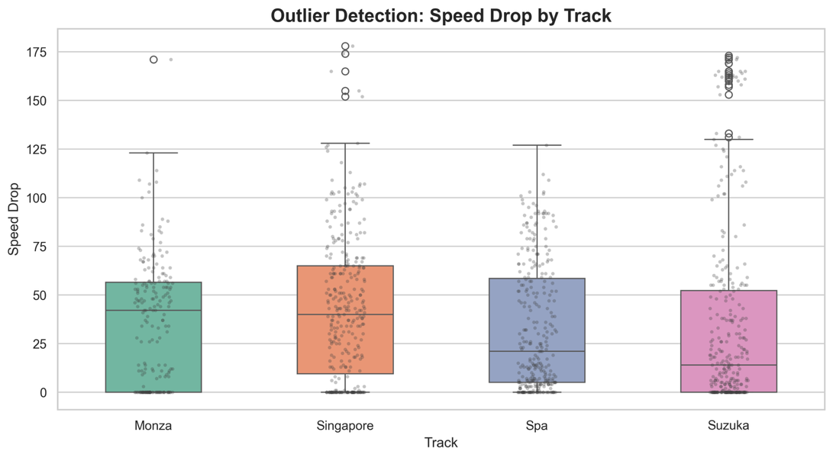
Figure 2: Outlier Detection for Speed Drop by Track, showcasing the extreme deceleration needed in specific turns.
We can see that in almost every race, there are extreme oultiers.
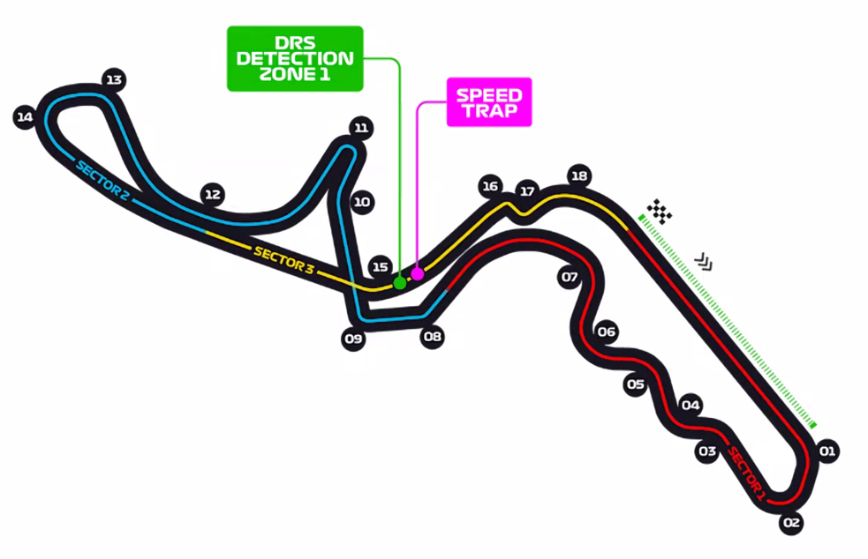
The reason for this massive number of outliers and extreme outliers, is the difference between the turns themselves. For example, in Suzuka, there is one specific turn, marked 11 on the following map, that forces the driver to decelerate extremely to succeed it.
Figure 3: Suzuka Circuit Map Highlighting Turn.

This turn explains the massive number of outliers in terms of speed drop, there are only 20 samples, one from each driver in this racetrack, that require such a massive speed drop.

Those extreme outliers draw the center of the clusters towards them and thereby affect the clustering process.

3.5 Representation:

To evaluate the necessity of dimensionality reduction, we tested clustering algorithms on both the normalized raw features and a reduced dataset. For the reduction process, we utilized Principal Component Analysis (PCA(.

PCA Algorithm Overview: PCA is an unsupervised dimensionality reduction technique that transforms a dataset of highly correlated variables into a smaller set of linearly uncorrelated variables, known as principal components. It achieves this by projecting the original data onto a new orthogonal subspace that maximizes the retained variance. This process effectively compresses the data and filters out noise while preserving the core underlying patterns.

Comparison with t-SNE: We also evaluated t-Distributed Stochastic Neighbor Embedding (t-SNE) as an alternative dimensionality reduction technique. While t-SNE is highly effective for 2D or 3D visual exploration due to its ability to preserve local non-linear data structures, it proved unsuitable for our specific clustering pipeline. t-SNE distorts the global distances and densities between clusters. Since our subsequent step relied on K-Means – a distance-based algorithm – maintaining the true mathematical distances and global variance between driving behaviors was essential. Therefore, PCA’s linear transformation was the mathematically appropriate choice for generating the input space for K-Means.

Application and Configuration: Our engineered telemetry features (such as entry speed, braking percentage, and throttle application) inherently exhibited high multicollinearity. We configured the PCA algorithm to retain 95% of the total data variance. This threshold efficiently reduced our feature space from 12 original variables down to 9 principal components ($k=9$). We briefly considered Non-Negative Matrix Factorization (NMF) as an alternative; however, because our preceding standardization step introduced negative values, NMF was mathematically inapplicable.

Impact on Clustering: The application of PCA was critical to the success of our model. When clustering algorithms were run directly on the original 12-dimensional space, the boundaries between the driving styles were blurred due to feature noise and the "curse of dimensionality." By applying PCA first, we bypassed these issues. The resulting clusters were significantly more distinct and mathematically cohesive, allowing for a clean, interpretable separation of cornering profiles.

Clustering Architecture and Configuration (K-Means): Following the dimensionality reduction step, we applied the K-Means clustering algorithm to partition the 9-dimensional principal component space into distinct driving behavior profiles. K-Means is an unsupervised, centroid-based algorithm that iteratively assigns each data point to the nearest cluster center while minimizing the within-cluster sum of squares (inertia) using Euclidean distance. To determine the optimal number of clusters (k), we evaluated the model's performance across a range of values using both the Elbow method – analyzing the inflection point of the total within-cluster variance – and Silhouette analysis to measure cluster separation and cohesion. Based on these metrics, the optimal configuration was determined to be $k=3$.

Density-Based Clustering and Outlier Detection (DBSCAN): In parallel, to capture more complex, non-spherical structures and effectively manage outliers within the telemetry dataset, we evaluated Density-Based Spatial Clustering of Applications with Noise (DBSCAN). Unlike K-Means, DBSCAN does not require a prior specification of the number of clusters; instead, it defines clusters based on the local density of data points. The algorithm relies on two primary hyperparameters: epsilon ($ε$), which specifies the maximum neighborhood radius, and MinPts, the minimum number of points required to form a dense region. By identifying core points, border points, and noise, DBSCAN allowed us to isolate irregular driving behaviors and filter out anomalous telemetry lines that could otherwise distort the primary behavioral profiles. This density-based approach failed to provide meaningful results due to the nature of the data.

4 Results

4.1 Clustering Analysis:
We evaluated two clustering algorithms, DBSCAN and K-Means, to identify distinct driving styles from Formula 1 telemetry data.
- DBSCAN
Algorithm & Parameters: A density-based algorithm where we tuned the radius (eps) and minimum samples (min_samples).
Advantages: Generally effective at finding irregularly shaped clusters and ignoring outliers.
Disadvantages for this dataset: Struggled with the continuous nature of F1 telemetry. Since the data flows continuously rather than forming isolated pockets, DBSCAN either classified most corners as noise (when eps was too small) or merged everything into a single cluster (when eps was too large).
- K-Means (Selected Method)
Algorithm & Parameters: A centroid-based algorithm that partitions data into a predefined number of clusters. We utilized a two-step pipeline, using $k=3$for both steps.
Choosing the Number of Clusters: We evaluated the optimal number of clusters using two metrics: the Silhouette Score (which indicated $k=2$) and the Elbow Method (which suggested $k=4$). To balance mathematical cohesion with the practical complexity of different driving styles, we compromised and selected $k=3$.
Advantages for this dataset: Actively partitions continuous space into distinct groups, ensuring every single cornering event is explicitly categorized.

Final Selection & Justification
We ultimately selected K-Means. DBSCAN was discarded because its density-based approach is strictly incompatible with our continuous, non-pocketed telemetry data flow. K-Means proved vastly superior, allowing us to successfully categorize the data through a two-step pipeline:
- Cornering Styles: Clustering the principal components of the corners ($k=3$) to define base styles.
- Driver Profiles: Clustering the percentage distribution of each driver's cornering styles ($k=3$) to group the drivers into distinct behavioral categories.

4.2 Cluster Evaluation:
Since our earlier analysis ruled out DBSCAN, our evaluation focused on assessing the quality of our K-Means clusters and, most importantly, measuring the impact of dimensionality reduction on the results.
We evaluated our pipeline by comparing two approaches: clustering directly on the 12 normalized features ("No PCA") versus clustering on the principal components ("PCA First").
Visual and Structural Separation: When evaluating the "No PCA" results, the 2D visual projection showed that the clusters were highly overlapping and the boundaries between the driving styles were blurred. The algorithm struggled to separate the data cleanly due to the noise in the high-dimensional space. In contrast, the "PCA First" approach yielded highly definitive, well-separated macro-clusters. By retaining 95% of the variance, PCA successfully filtered out the noise, allowing K-Means to identify much more cohesive and distinct driving behaviors.
Mathematical Evaluation: To evaluate the optimal configuration for our clusters, we utilized two metrics. The Silhouette Score indicated that $k=2$ was optimal, while the Elbow Method suggested $k=4$. Rather than relying blindly on a single metric, we combined these mathematical results with the real-world context of Formula 1. We concluded that $k=3$ offered the best compromise, balancing mathematical cohesion with a practical, meaningful division of racing styles.
Ultimately, the evaluation proved that applying PCA before K-Means dramatically improved cluster quality, making it our definitive recommendation for this dataset.

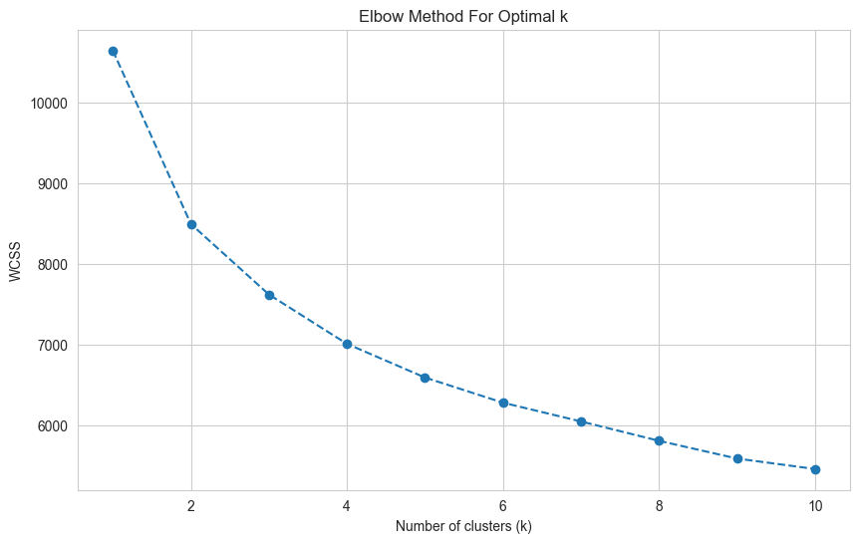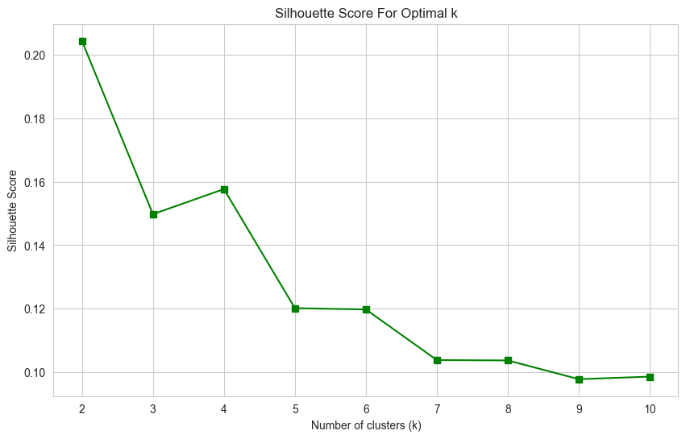
Figure 4: Elbow Method for determining the optimal number of clusters (k), showing a bend at k=4.
Figure 5: Silhouette Score evaluation, indicating maximum mathematical cohesion at k=2.

4.3 Cluster Interpretation:
After clustering the driver profiles into three distinct groups, we analyzed the underlying telemetry features to interpret what each cluster represents in the real world. We successfully identified three distinct driving styles, visually mapped by color in our final plots:
The Aggressive Style (Red Cluster): Drivers in this cluster push the car to its limits. They are characterized by significantly higher entry and exit speeds, massive speed drops, and very late, harsh braking. They spend a large percentage of the corner applying heavy throttle to accelerate out as quickly as possible.
The Conservative Style (Green Cluster): This cluster represents drivers who prioritize stability and smoothness. They tend to have lower entry speeds, brake earlier and for a longer duration, and apply the throttle more gradually. Their speed drops are less extreme, indicating a smoother cornering momentum.
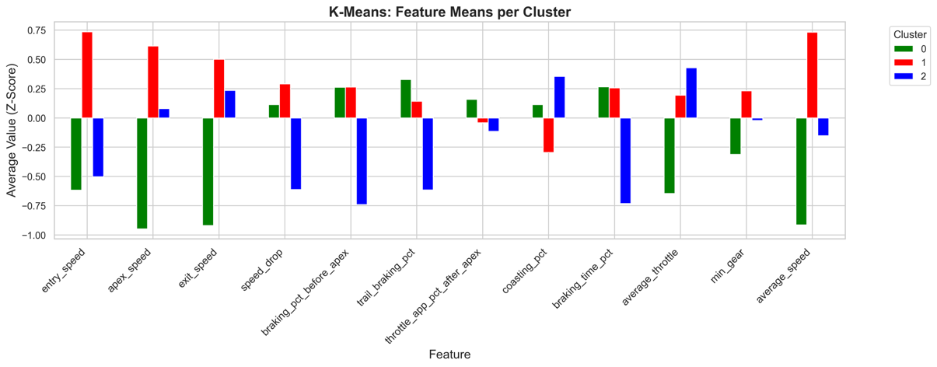
The Balanced Style (Blue Cluster): As the name suggests, drivers in this blue cluster sit right in the middle. They adapt their driving style depending on the specific track or corner, balancing the harsh inputs of the aggressive drivers with the smooth momentum of the conservative drivers.
Figure 6: K-Means feature means per cluster (Z-scores), clearly illustrating the distinct driving styles: Aggressive (Cluster 1, Red), Conservative (Cluster 0, Green), and Balanced (Cluster 2, Blue).

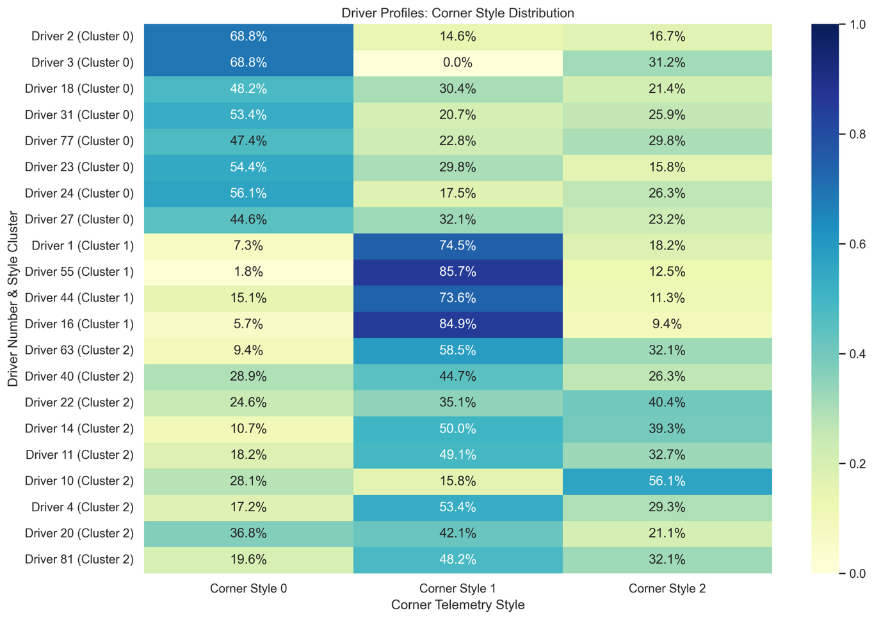
After clustering the individual cornering events, we aggregated the data per driver to create a new dataset representing the probability distribution of their cornering styles across the defined clusters. We then performed a second round of clustering on this new dataset, which successfully categorized the drivers based on their overall driving styles.
Figure 8: A heatmap matrix, based on the percentage distribution of corner telemetry styles, defining the behavioral profile for each driver. Drivers are grouped based on their final k-means cluster assignment.
Figure 7: A visual matrix, displaying the raw number of corner events per driver that were categorized into each of the three cornering style clusters. Darker cells represent higher corner counts, forming the basis for subsequent driver profile analysis.
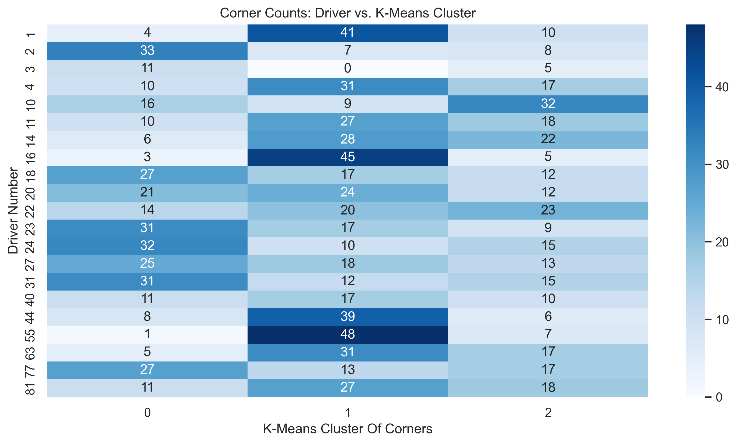

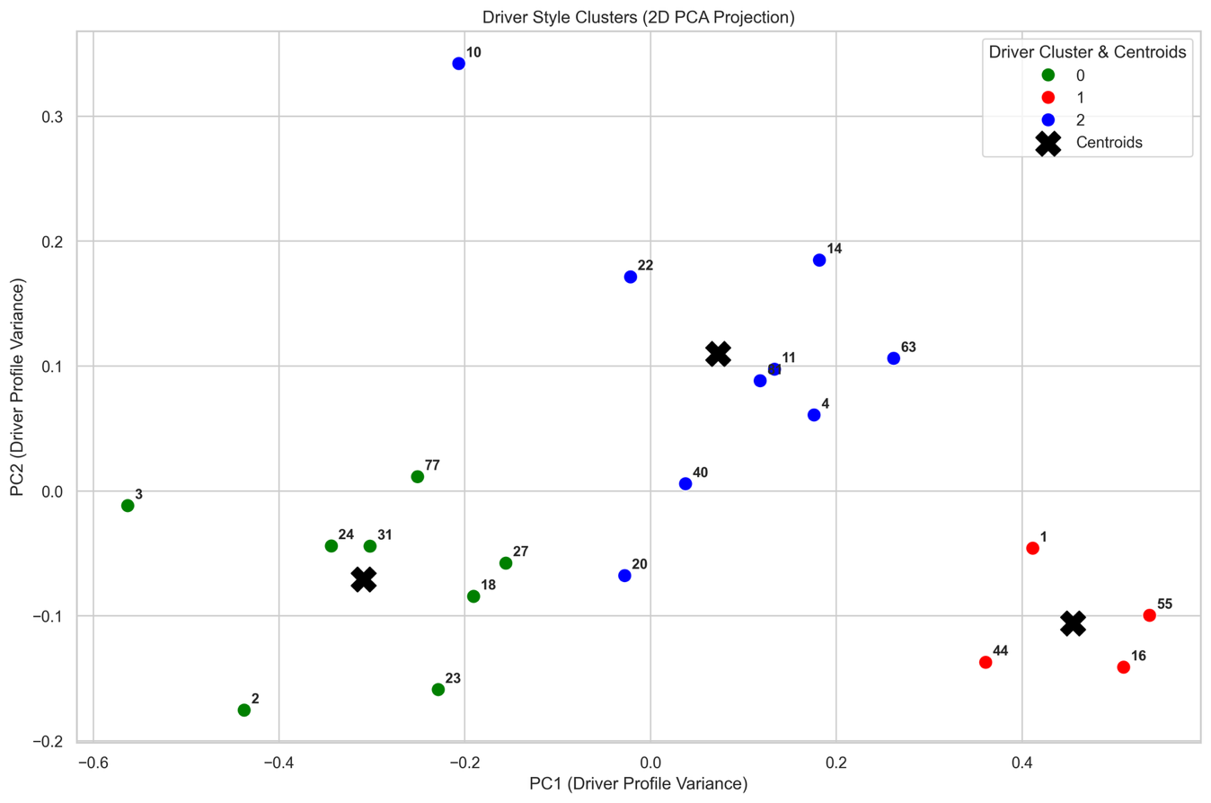
Figure 9: A 2D PCA projection of the final K-Means clustering results, illustrating the spatial separation of the drivers into three distinct behavioral profiles along with their respective centroids.
5 Conclusions and Discussion:

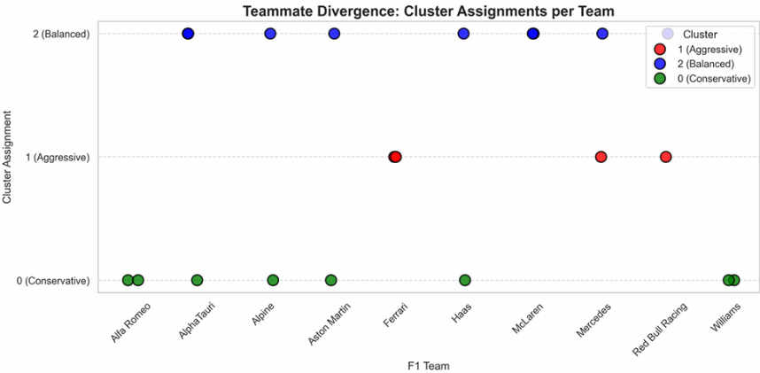
Returning to our original project question, we can confidently conclude that Formula 1 drivers indeed possess distinct, mathematically quantifiable driving styles. The clustering process successfully revealed three main profiles (aggressive, balanced, and conservative). These findings strongly support our initial hypothesis that raw telemetry data alone is sufficient to uncover personal driving behaviors. Furthermore, our analysis debunked the "car decides the result" myth, as we observed teammates driving identical cars falling into entirely different driving style clusters.
Figure 10: Driving Style Distribution by Team. A breakdown of cluster assignments per constructor, revealing whether teams employ drivers with similar or contrasting driving styles
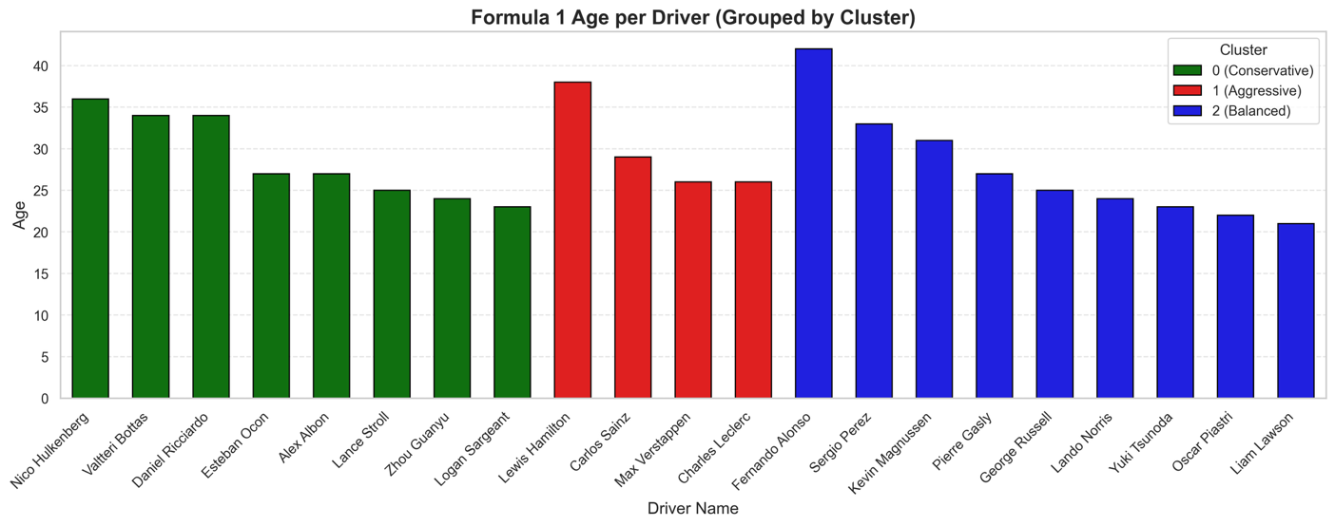
Finally, we analyzed the relationship between the identified driver profiles and demographic factors. Our results conclusively show zero correlation between a driver's style and their age or years of experience. We therefore conclude that driving style is an inherent behavioral trait, completely unaffected by a driver's age or tenure in the sport.
Figure 12: Age distribution across the three driving style clusters, demonstrating the lack of correlation between a driver's age and their behavioral profile.

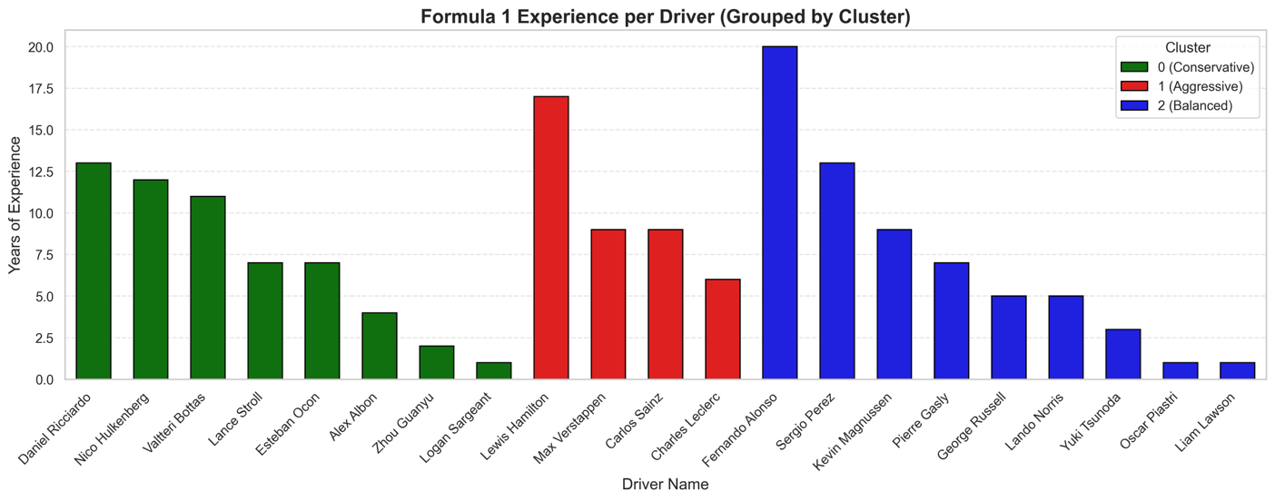
Figure 11: Experience distribution across the three driving style clusters, demonstrating the lack of correlation between a driver's experience and their behavioral profile.

One of the most fascinating insights we learned from the clustering relates to race performance. We found a clear correlation between driving style and success: the more aggressive the driver, the better their expected average standing. Visually, as a driver's profile is positioned further to the right on our PCA cluster graph (indicating higher aggressiveness), their final race results tend to be more successful (see figure 9).
Limitations: Our analysis is primarily limited by the data structure. The OpenF1 API data has missing values and gaps (such as sensor blackouts between the start and end of laps). Furthermore, the 3.7Hz sampling rate means we lose a few meters of crucial tracking data every second. Additionally, our dataset was limited to the fastest qualifying laps from four tracks, which might not fully capture a driver's behavior during actual race conditions (e.g., fighting for position or tire degradation).
Future Directions: For future research, we could expand the dataset to include full race telemetry rather than just qualifying laps. It would also be highly interesting to analyze how a driver's style shifts under different weather conditions (wet vs. dry tracks) or as their tire compounds degrade over a longer stint.

Amazon Web Services (AWS), “F1 Insights powered by AWS.” [Online]. Available: https://aws.amazon.com/sports/f1/. [Accessed: June 27, 2026].
A. Sasikumar, A. A. Leema, and P. Balakrishnan, "Data-driven pit stop decision support for Formula 1 using deep learning models", Frontiers in Artificial Intelligence, 2025. [Online]. Available: https://pmc.ncbi.nlm.nih.gov/articles/PMC12626961/.
cld05, "F1_tracks_clustering", GitHub repository. [Online]. Available: https://github.com/cld05/F1_tracks_clustering. [Accessed: June 27, 2026].

